**Assignment - 19 A Job Ready Bootcamp in C++, DSA and IOT**

Handling multiple Strings in C Language

**1. Write a program to find the number of vowels in each of the 5 strings stored in two dimensional arrays, taken from the user.**

#include <stdio.h>

#include <string.h>

int main()

{

char str[5][15];

int i,j,count;

printf("Enter strings\n");

for(i=0;i<5;i++)

{

gets(str[i]);

}

printf("No. of voweles in given strings :\n");

for(i=0;i<5;i++)

{

for(j=0;str[i][j]!='\0';j++)

{

if(str[i][j] =='a'|| str[i][j]=='e'|| str[i][j]=='i'|| str[i][j]=='o'|| str[i][j]=='u')

count++;

}

printf("%s = %d\n",str[i],count);

count=0;

}

return 0;

}

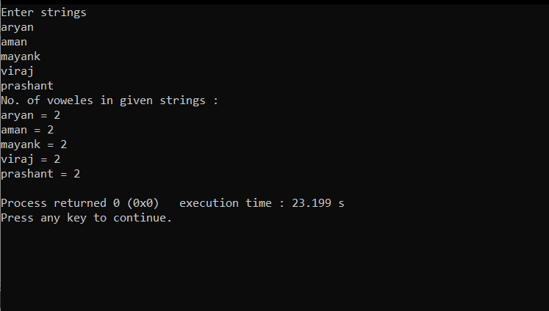

**2. Write a program to sort 10 city names stored in two dimensional arrays, taken from the user.**

#include <stdio.h>

#include <string.h>

int main()

{

char str[10][15];

char temp[15];

int i,j;

printf("Enter 10 city names :\n");

for(i=0;i<10;i++)

{

gets(str[i]);

}

printf("City names is sorted Order :\n");

for(i=0;i<10;i++)

{

for(j=i+1;j<10;j++)

{

if(strcmp(str[i],str[j]) > 0)

{

strcpy(temp,str[j]);

strcpy(str[j],str[i]);

strcpy(str[i],temp);

}

}

}

for(i=0;i<10;i++)

printf("%s\n",str[i]);

return 0;

}

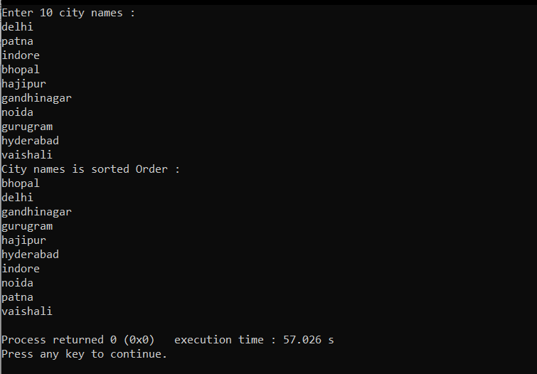

**3. Write a program to read and display a 2D array of strings in C language.**

#include <stdio.h>

#include <string.h>

int main()

{

char str[5][15];

int i,j;

printf("Enter 5 city names :\n");

for(i=0;i<5;i++)

{

gets(str[i]);

}

printf("Strings are :\n");

for(i=0;i<5;i++)

{

for(j=0;str[i][j];j++)

{

printf("%c",str[i][j]);

}

printf("\n");

}

return 0;

}

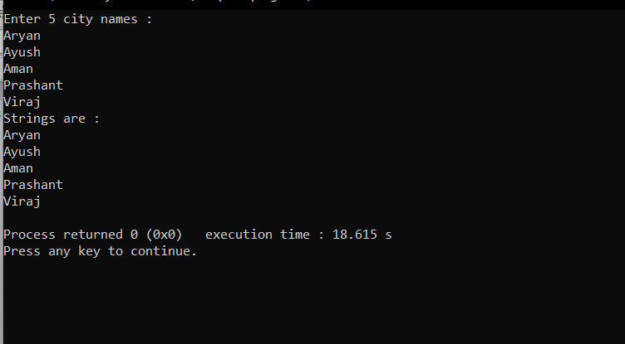

**4. Write a program to search a string in the list of strings.**

#include <stdio.h>

#include <string.h>

int main()

{

char str[5][15],scr[15];

int i;

printf("Enter five strings :\n");

for(i=0;i<5;i++)

{

gets(str[i]);

}

printf("Enter string that we have to search in the given strings:\n");

gets(scr);

for(i=0;i<5;i++)

{

if(strcmp(str[i],scr)==0)

{

printf("\n....String found.....");

return 0;

}

}

printf("\n.....string Not found......");

return 0;

}

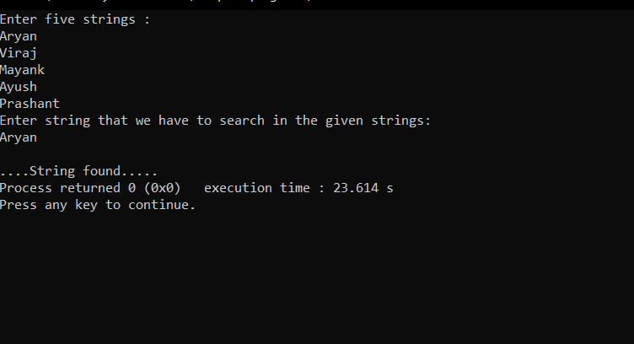

**5. Suppose we have a list of email addresses, check whether all email addresses have ‘@’ in it. Print the odd email out.**

#include <stdio.h>

#include <string.h>

int main()

{

char str[5][25];

int i;

printf("Enter three email address :\n");

for(i=0;i<5;i++)

{

gets(str[i]);

}

printf("\nOdd emails are :\n");

for(i=0;i<5;i++)

{

if(strchr(str[i],'@')== 0)

printf("%s\n",str[i]);

}

return 0;

}

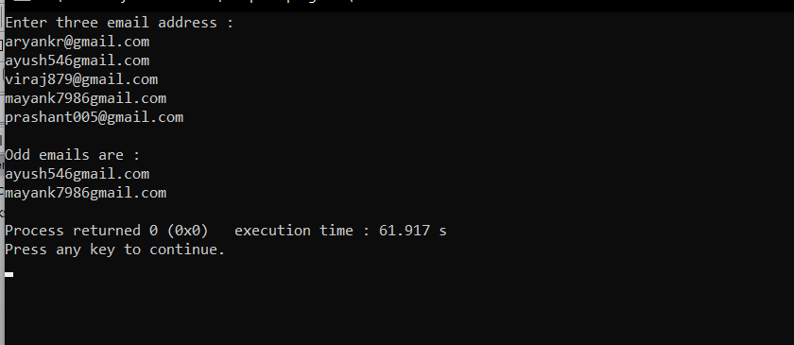

**6. Write a program to print the strings which are palindrome in the list of strings.**

#include <stdio.h>

#include <string.h>

int main()

{

char str[6][25],str2[25]={0};

int i,j;

printf("Enter strings :\n");

for(i=0;i<6;i++)

{

gets(str[i]);

}

printf("\n......Check string is palindrome or not......\n\n");

for(i=0;i<6;i++)

{

strcpy(str2,str[i]);

strrev(str[i]);

{

if(strcmp(str[i],str2) == 0 )

printf("%s - is palindrome\n",str[i]);

}

}

return 0;

}

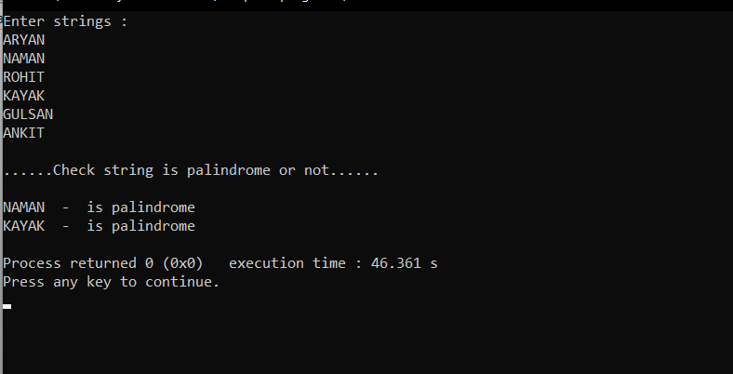

**7. From the list of IP addresses, check whether all ip addresses are valid.**

#include <stdio.h>

#include <string.h>

int main()

{

char ip[5][20],n[20]={0};

char *a;

int i,x,k,c;

printf("Enter ip addresses :\n");

for(i=0;i<5;i++)

{

gets(ip[i]);

}

printf("\n......Check ip address are valid or not or not......\n\n");

for(i=0;i<5;i++)

{

strcpy(n,ip[i]);

a=strtok(ip[i],".");

k=0;

c=0;

while(a!=NULL)

{

x=atoi(a);

if((x>=0) && (x<=255))

{

c++;

}

k++;

a= strtok(NULL,".");

}

if(k==4 && c==4)

printf("%s -- Is valid ip address\n",n);

else

printf("%s -- Is not valid ip address\n",n);

}

return 0;

}

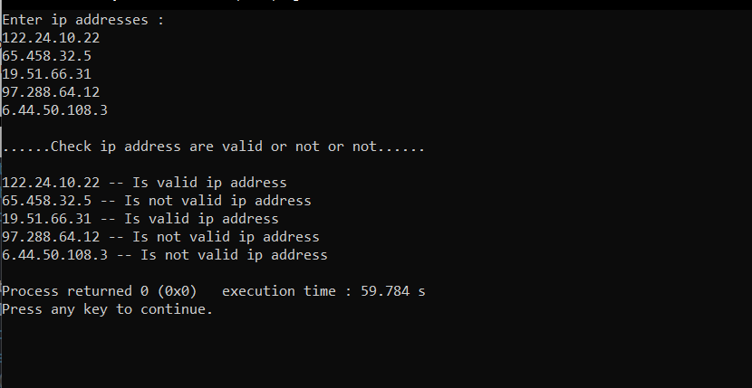

**8. Given a list of words followed by two words, the task is to find the minimum distance between the given two words in the list of words.**

**(Example : s = {“the”,”quick”,”brown”,”fox”,”quick”}**

**word1 = “the”, word2 = “fox”, OUTPUT : 1 )**

#include <stdio.h>

#include <string.h>

int main()

{

char str[5][20]={"my","name","name","is","aryan"};

char n1[10],n2[10];

int i,x1=-1,x2=-1,min=1000,temp;

printf("Enter two word from the list to find distance between them\n");

gets(n1);

gets(n2);

for(i=0;i<5;i++)

{

if(strcmp(str[i],n1)==0)

x1=i;

if(strcmp(str[i],n2)==0)

x2=i;

if(x1!=-1 && x2!=-1)

{

temp = abs(x2-x1);

if(temp<min)

min=temp;

}

}

printf("%d",min-1);

return 0;

}

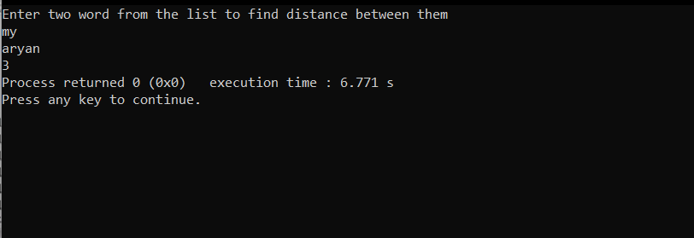

**9. Write a program that asks the user to enter a username. If the username entered is one of the names in the list then the user is allowed to calculate the factorial of a number. Otherwise, an error message is displayed**

#include <stdio.h>

#include <string.h>

int fact()

{

int i,num,f=1;

printf("Enter a number ");

scanf("%d",&num);

for(i=1;i<=num;i++)

{

f*=i;

}

return f;

}

int main()

{

char str[5][20]={"Aryan","Ayush","Viraj","Prashant","Utkarsh"};

printf("Enter username : ");

char n[20];

int i,flag=0;

gets(n);

for(i=0;i<5;i++)

{

if(strcmp(str[i],n)==0)

{

printf("factorial of the number is : %d",fact());

flag=1;

}

}

if(flag==0)

printf(" ...Error... ");

return 0;

}

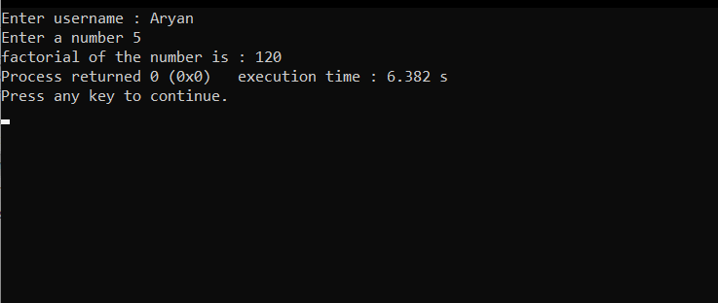

**10. Create an authentication system. It should be menu driven.**

#include <stdio.h>

#include <string.h>

int main()

{

char str[3][2][20]={

{

"Aryan","123"

},

{

"Ayush","456"

},

{

"Viraj","789"

}

};

char username[10];

char password[10];

int i,flag=0;

printf("Enter username and password \n");

gets(username);

gets(password);

for(i=0;i<3;i++)

{

if(strcmp(username,str[i][0])==0 && strcmp(password,str[i][1])==0)

{

printf("Login sucessful...");

flag=1;

}

}

if(flag==0)

printf("Username password not matched");

return 0;

}

